1. What is Emmet?

* Emmet is a plug-in for many popular text editors which greatly improves HTML & CSS workflow.

1. Difference between a Library and Framework?

* A library is a collection of packages that perform specific operations whereas a framework contains the basic flow and architecture of an application.
* The major difference between them is the complexity.
* Libraries contain a number of methods that a developer can just call whenever they write code.
* React js is library and Angular is framework.
* The framework provides the flow of a software application and tells the developer what it needs and calls the code provided by the developer as required.
* If a library is used, the application calls the code from the library.

1. What is CDN? Why do we use it?

* CDN (content delivery network):
  + A CDN is a network of interconnected servers that speeds up webpage loading for data – heavy applications.
  + When a user visits a website, data from that website’s server has to travel across the internet to reach user’s computer. If the user is located far from that server, it will take a long time to load a large file, such as video or website images.
  + Instead website content is stored on CDN servers geographically closer to the users and reaches their computers much faster.
* Why is CDN important?
  + The primary purpose of CDN is to reduce latency, or reduce the delay in communication created by network’s design.
  + A CDN improves efficiency by introducing intermediary servers between client and website server.
  + These CDN servers manage some of client – server communications. They decrease web traffic to the web server, reduce bandwidth consumption, and improve the user experience of your applications.

1. Why is React known as React?

* React is a JS library for building user interfaces. It was developed by Facebook developers and the name React was chosen because it is meant to help developers building user interfaces that are fast and responsive, or reactive. The library was designed to react to changes in data.
* When data in a React application changes, the components that depend on that data are automatically updated, which allows for efficient and seamless updates to the user interface. The name React reflects this reactive nature of the library.
* The idea behind React is to build reusable components that can be rendered on the front-end, rather than writing a new piece of code every time you need to display something on the screen. This makes it easier and more efficient to build complex user interfaces.

1. What is crossorigin in script tag?

* Crossorigin attribute is used when a script on one domain is trying to fetch or interact with resources from another domain.
* Here, we’re fetching CDN links of react:

* The crossorigin can have two values:
  + crossorigin = “anonymous”
    - It means that the script should be fetched without sending any credentials (like cookies or HTTP authentication). This is suitable for scripts that are public or don’t require authentication.
* crossorigin = “use-credentials”
  + It means that the script should be fetched with credentials. This is appropriate when the script requires an authentication or if the server needs to identify the user making the request.

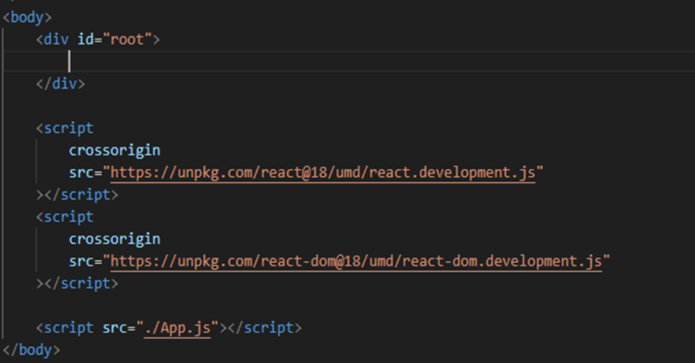

1. What is difference between React and ReactDOM?

* React is a JS library for building user interfaces (UIs) whereas ReactDOM is also a JS library that allows React to interact with the DOM.
* The react package contains React.createElement(), React.Component, React.Children, and other helpers related to elements and component classes. You can think of these as the isomorphic or universal helpers that you need to build components.
* The react-dom package contains ReactDOM.render(), and in react-dom / server we have server-side rendering support with ReactDOMServer.renderToString() and ReactDOMServer.renderToStaticMarkup().

1. What is difference between react.development.js and react.production.js files via CDN?
   * Development (Dev) Link:
     + The development link is typically used during the development phase of your application.
     + It includes additional debugging tools, warnings, and helpful error messages.
     + It is larger in file size and may negatively impact the performance of your application.
     + It is not optimised for production use.

* Production (Prod) Link:
  + The production link is meant for deploying your application in a production environment.
  + It excludes development-specific tools, warnings, and error messages.
  + It is smaller in file size, which improves the performance of your application.
  + It is optimized for production use.

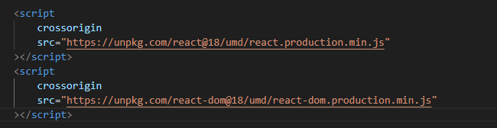

* **NOTE :**
  + Using the development link in a production environment can lead to unnecessary debugging information being sent to the client, which may be a security risk and can negatively affect performance.
  + Conversely, using the production link during development may make it difficult to identify and debug issues because you won’t get helpful error messages and warnings.

1. What is async and defer?
   * Both are boolean attributes which are used along with script tag to load the external scripts efficiently in our web page.
   * Async:
     + HTML parsing goes on and the scripts are fetched in async manner and parallely and as soon as scripts are available the script is executed and after only HTML parsing continues.

* Differ:
  + HTML parsing goes on and the scripts are fetched parallely and only executed once HTML parsing is complete.
* **NOTE :**
  + Async attribute does not guarantee the order of execution of script but differ does.
    - If you’re putting “async” attribute in multiple scripts which are dependent on each other, then executing “async” tag does not guarantee you that these scripts will be executed in order. This may break down our code.
      * *In this case, we should probably prefer “defer”.*
* Suppose you’ve to load some external scripts (which are quite modular & independent of normal code). *So, in this case it’s better to use async attribute.*